

IE-468 Case 2

Bilgehan Güçlü Özkan 22003839

Ahmet Sayan 21903426

Damla Uçar 22103276

Q1)

Using the data for riders riding from MiMA to UES we fitted 2 price response functions by using linear regression as the riders have 2 segments; Regular and EduPass.

Regular Linear Price Function from MiMA to UES:

d(p) = 496.9819 - 2.4593\*p

EduPass Linear Price Function from MiMA to UES:

d(p) = 120.0882 - 0.8868\*p

We believe both of these functions are a good fit since our $R^{2}$ value for regular customers is 0.9785 and for EduPass customers it is 0.9388, meaning we can explain 97.9% and 93.9% of the variation in our data sets.

Q2)

For the capacity of 262 bikes, including the ones stationed in MiMA and those ridden from the UES previously we calculated the demand for both segments of customers at price p = 100. Using the previously calculated price response functions we calculated expected demand as 251 regular riders and 31 EduPass riders.

From this we can see that the service rate for our riders is 282/262 = 92.7%. To calculate total profit, we calculated profit per ride for both customer segments by using price, costs and average travel time, which we calculated as:

$$Avg Time=\frac{\left(\frac{Total Revenue}{Demand}\right)-Unlock Price*p}{Per min. Price*p}=17.004 min$$

So profit per ride at price 100 came out to be 9.6512$ for regular riders and 4.6006 for EduPass riders. Multiplying these figures with demands given a service rate of 92.7%.

Profit for Regular: 2247.45$

Profit for EduPass: 134.03$

Total Profit: 2381.476$

Q3)

Disregarding the previous service rate we’d have a total profit of 2567.45$ meaning we lose 185.97$ of profit due to having a shortage of 20 bikes, meaning the maximum price the company should be willing to pay for more capacity is 9.0896$ per bike.

Q4)

Using dynamic pricing we change the price from 100 to the optimal price for the two segments separately to achieve maximum profit under capacity and pricing for EduPass constraints. We find these optimal prices by creating a model based on the price response functions in Q1.

Using the model, we achieved a revenue of 3173.85$ and a profit of 2610.45$ at prices; 112.6474 for regular riders and 87.9976 for EduPass riders. These prices resulted in riders using all 262 meaning the constraint is binding.

To find the maximum price the company would be willing to pay per additional bike we ran the same model without the capacity constraint. The results can be seen below.

So the maximum incentive to add more bikes, per bike, is:

$( 2613.39-2610.45 )/10=0.36\$$

Q5)

Using the same model with an added constraint for $P_{regular}=P_{EduPass}$ and a relaxation of EduPass price constraint, our optimal price for both of these segments will be: 106.1146. The expected revenue and profit will be 3141.82$ and 2578.41$ when limited by capacity because the constraint is binding at 262.

To calculate the value of additional bikes we solve the optimization with the capacity constraint removed.



Since there is only an extra profit of 0.087$ for an added 1.66 capacity we can say that there is no incentive for additional capacity.

Q6)

To understand if the day of week the effects the willingness to purchase for regular riders we used categorical regression to fit a model. The results show that the difference between the price responses for weekdays is not significant at a confidence of 0.05.

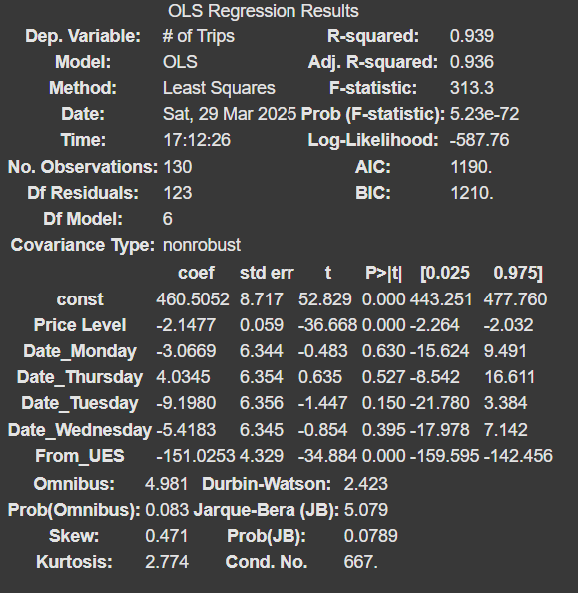

And with a $R^{2}$ value of 0.939 we are confident that this is the case.

Q7)

To find the optimal prices for UES to MiMA Regular, MiMA to UES Regular, and MiMA to UES EduPass rides we will need the price response function of UES to MiMA Regular riders in addition to the functions we found in Q1. For this we fitted a linear regression model to the data of MiMA to UES Regular riders.

Regular Linear Price Function from UES to MiMA:

d(p) = 224.57 - 0.8868\*p

We believe that this function is a good fit since our $R^{2}$ value for is 0.8539. So we can use this function for the optimization model to determine the number of bikes that will be in MiMA at 17.00. The model is similar to the one described in Q4 but the capacity is calculated as 166 + the number of returns from UES to MiMA Regular rides and our objective of maximising profit now includes profit of Regular rides from UES to MiMA.

Solving the model, we get a revenue of 4832.19$ and a profit of 3966.71$. The capacity constraint isn’t binding however, leaving a capacity of 24.4 empty while using 272 bikes for the optimal solution. Meaning there is no value of bringing additional bikes to MiMA as the capacity is enough because of rides from UES.

Finally the optimal prices for UES to MiMA Regular, MiMA to UES Regular, and MiMA to UES EduPass rides is 110.152, 106.115 and 83.635 respectively.

Q8)

A logit function was fit as a function of the price level using the following formula:

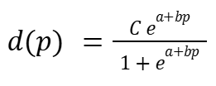

To transform this into a linear regression model, we took the logit transformation and obtained the following model:

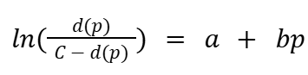

We then computed the demand for each price level and performed linear regression with price as the independent variable. This gave us, Intercept (a) = 2.99, Slope (b) = -0.02756

After obtaining the logit function, we rearranged it to solve for d(p) (estimated demand):

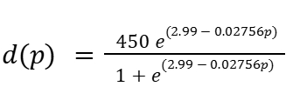

By this equation, we computed the estimated demand values for different price levels, and performed a second linear regression. The demand values were used as the dependent variable and price as the independent variable. This resulted in the following linear demand function:

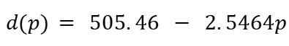

This revised regression model showed an improvement over the initial model, with increasing R-squared from 0.9785 to 0.9911. The standard error also decreased from 15.37 to 10.19. From these we can observe a better fit and more precise predictions.

Q9)

The calculations were repeated as in Question 4, with the change of using the logit function for estimating demand in Regular rides. The function used was:

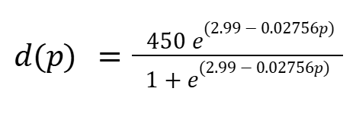

from Question 8. As a result, the logit model produced slightly lower optimal price levels for both Regular and EduPass riders compared to the linear model. This led to an increase in demand for Regular riders and a decrease in demand for EduPass riders.

Although the total profit from the logit model (2552.61) was slightly lower than that of the linear model (2610.45), the logit function provided a more accurate representation of real-world demand patterns. The logit model accounts for diminishing sensitivity to price changes, unlike the linear model which assumes demand decreases at a constant rate as price increases. This means that while demand is highly responsive at lower price levels, it stabilizes as prices rise. Relying on an incorrect linear function could result in overestimating profit potential and setting price levels that do not align with actual consumer behavior. This can affect revenue optimization and market competitiveness.